Determination of K_{M} and v_{max} for Alkaline Phosphatase
The object of this lab is to determine the Michaelis-Menten constants, K_{M} and v_{max}, for alkaline phosphatase. This enzyme removes phosphate groups from DNA and RNA. The enzyme also catalyzes the reaction shown in Figure 1. The reaction mixture turns yellow as the reaction proceeds. The color change allows the reaction to be followed with a spectrometer.
Figure 1. Hydrolysis of p-nitrophenylphosphate by alkaline phosphatase.
The substrate, pnpp, is present as a salt of tris, Figure 2, which, when protonated, has a positive charge.
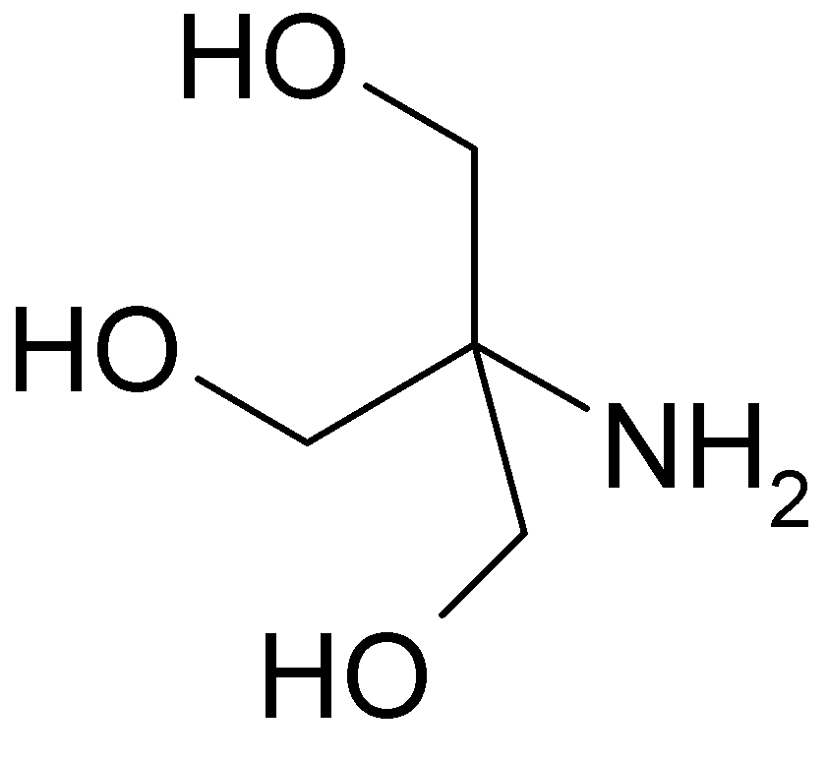
Figure 2. Tris, in unprotonated form.
In this lab the pnpp hydrolysis reaction will be followed by spectroscopy. Five cuvettes will be prepared. Each cuvette will contain substrate, buffer, and enzyme.
- Substrate: Each tube will contain a different amount of substrate, as calculated below.
- Buffer: Enough buffer will be added to each tube to give a final volume (after the enzyme is added) of 3.0 mL.
- Enzyme: The volume of enzyme solution added to each cuvette will be the same (about 0.2 mL).
The enzyme will be the last thing added to the cuvette, because, as soon as enzyme is added, the reaction starts. Immediately after the enzyme is added, the cuvette is placed in the spectrometer and its absorbance is recorded every 2.5 seconds for 3 minutes.
The five cuvettes are to contain 30, 60, 120, 300, and 600 nmol of substrate (a nanomole, nmol, is 1 × 10⁻⁹ mol). The initial concentration of substrate in each cuvette, [S₀], needs to be calculated, but that is simple: concentration is mol/L, so divide the number of moles in each tube by the total volume of solution in the cuvette in L (each cuvette contains 3.0 mL). For example, the first tube has [S₀] = 30 nmol/3 mL = 30 × 10^{–9} mol/(3.0 × 10^{–3} L) = 1.0 × 10^{–5} mol/L. Calculate [S₀] for the other 4 solutions, and record them in the first row of the following table.
The substrate is provided as a 0.003 M solution. Calculate how many µL of that solution should be added to each cuvette to provide the desired number of nmol, and recorded in the second row of the following table. For example, the first cuvette is to contain 30 × 10^{–9} mol. Molarity is defined as molarity = mol/L; the molarity is 0.003 M, the moles is 30 × 10^{–9} mol, solving for volume gives 1× 10^{–5} L. Converting to µL (1 µL = 1 × 10⁻⁶ L) gives 10 µL of substrate, which is how much is needed in the first cuvette.
In row 3 is shown the volume of substrate needed converted to mL (just divide µL by 1000 to get mL).
In row 4 calculate how much buffer solution needs to be added to make the total volume be 3 mL. Each cuvette will contain 0.2 mL of enzyme solution, the volume of stock substrate solution calculated above, and buffer. For example, for the first cuvette, buffer + 0.2 mL + 0.01 mL = 3 mL, so buffer will be 2.79 mL.
Amount of substrate | 30 nmol | 60 nmol | 120 nmol | 300 nmol | 600 nmol
Concentration of  substrate, [S₀] / M | 1× 10^{–5}
Volume of 0.003 M  substrate in µL | 10
Volume of 0.003 M  substrate in mL | 0.01
Volume of buffer in mL | 2.79

Solutions provided (may have students help make these):
Substrate, 0.003 M p-nitrophenyl phosphate in 0.2 M Tris-HCl (pH 8.0), placed in hood 1, along with autopipets that deliver from 10 µL to 200 µL.
Preparation: 25 mL 0.003 M p-nitrophenyl phosphate in 0.2 M tris, pH 8.0
To a 25 mL volumetric flask, add 0.0346 g of p-nitrophenyl phosphate di(tris). Dilute to the mark with 0.2 M tris buffer. Store on ice.
Buffer, 0.2 M Tris-HCl (pH 8.0), placed in hood 2, along with autopipets that deliver from 1.5 to 3 mL.
Preparation: 1 L 0.2 M Tris HCl buffer, pH 8.0
To a 1 L volumetric flask (accuracy isn’t important) add 16.1 g “Trizma Base” and 10.6 g “Trizma HCl”. Dilute to the mark with deionized water. Label the bottle “0.2 M Tris buffer, pH 8”.
Enzyme solution, ≈15 mU/200 µL alkaline phosphatase, placed in hood 3 in a 50 mL centrifuge tube clamped to a ring stand. A bag of 1.5 mL plastic centrifuge tubes is also in this hood, and a 1.5 mL autopipet.
Preparation: 50 mL 15 mU/0.2 mL alkaline phosphatase
Stock solution (from Fisher) is 20 U/µL. Need 3.75 U. Dissolve 7.5 µL of enzyme in glycerol in 50 mL of tris buffer, pH 8.0. Be careful not to use the wrong tube: the enzyme may be shipped with a buffer tube that is in the same size tube as the enzyme.
Product, 0.000050 M p-nitrophenol. This is in hood 4.
Preparation, stock solution: 500 mL 0.050 M p-nitrophenol (139.11 g/mol) in 0.2 M tris buffer, pH 8.0.
Dilute 0.0035 g p-nitrophenol to 500 mL in a volumetric flask with the pH 8 buffer. Transfer the solution to a plastic container. Label the container “Stock 0.050 M p-nitrophenol in pH 8 buffer”.
Preparation, diluted solution: 100 mL 0.000050 M p-nitrophenol (139.11 g/mol) in 0.2 M tris buffer, pH 8.0.
Place 1 mL of the 0.050 M p-nitrophenol stock solution in a 1 L volumetric flask. Dilute to the mark with in the pH 8 buffer. Transfer the solution to a plastic container labeled “0.000050 M p-nitrophenol in pH 8 buffer”.

Procedure
Obtain 7 cuvettes and one lid.
Obtain a supply of the enzyme solution. From hood 3, obtain a small plastic 1.5 mL centrifuge tube. To that tube add 1.5 mL of the enzyme solution. Each of the six rows in the lab will share a 200 µL pipette for transferring enzyme from the 1.5 mL storage container into the cuvette.
Prepare a blank: The substrate gradually decomposes, and develops a slight yellow color soon after the solution is prepared. This would cause the initial reading of a run to be greater than zero. To correct for that, the blank is the solution containing substrate and buffer, but no enzyme. So, using the calculations above, prepare a blank by adding to a cuvette the amounts of substrate and buffer needed for the “600 nmol” run. (Don’t worry about the volume not being exactly 3 mL.) Pipettes for transferring these solutions are in the hoods where these solutions are stored. Mix the contents by putting a lid on the cuvette and inverting it a couple of times.

Connect SpectroVis Plus to a Computer
- Connect the SpectroVis Plus to a USB port on the computer.
- Double click the Logger Pro 3 icon on the desktop.

Calibrate SpectroVis Plus
- Choose from the “Experiment” menu Calibrate Spectrometer 1. Wait until the system finishes warming up (90 seconds).
- Wipe the smooth surfaces of the “blank” cuvette (prepared above) with a tissue paper. The software will have a dialog box saying “Place a blank cuvette in the device:”. Do so. Check that the light from the spectrometer is shining on the smooth surface of the cuvette, as in figure 1.
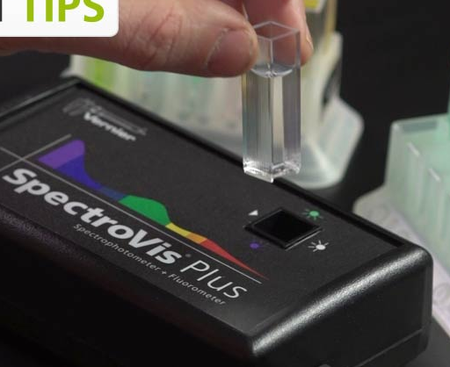
ribbed
clear
Figure 1. A cuvette being inserted into the spectrometer.
- Click “Finish Calibration”, then click OK.
- Save the blank cuvette in case the blank needs to be checked again.

Determine the Maximum Wavelength & Set Up the Data Collection Mode
In this lab we will watch the yellow product being produced. To do that, the wavelength where the product absorbs needs to be determined. A “product” solution is provided for this purpose.
- Rinse a cuvette twice with a small amount of the “Product” solution, then fill the cuvette ¾ full with that solution and place it in the spectrophotometer.
- Start data collection by clicking the button. A full spectrum graph of the solution will be displayed. Note that one area of the graph contains a peak absorbance, and there may be other lesser peaks that characterize this substance. Stop the data collection by clicking the button.
- Store the run by choosing from the “Experiment” menu “Store Latest Run”.
- To set up the data collection mode, click the Configure Spectrometer button, . Click Abs vs. Time as the Collection Mode. The wavelength of maximum absorbance (λ_{max}) will be selected. (This should be around 400 nm). Select OK. The spectrometer will display the absorbance at the selected wavelength. Record this value, which is the absorbance of the product at its λ_{max}. ________________
- Click the “Data Collection” button, , and select a “Duration” of 180 seconds, and “Sample Rate” of 0.4 samples/second (that’s 2.5 seconds per sample).

Collect Absorbance-Time Data (Kinetics)
- For the first run, use the cuvette that had the product solution in it. The product solution can be poured back into the beaker it came from. Rinse the cuvette with water to get every bit of the yellow out, so as not to mess up the absorbance readings.
- The cuvette is to hold a total of 3 mL of solution. To the cuvette add 200 µL of the substrate and 2.6 mL of buffer. 200 µL of enzyme solution is about to be added to the cuvette. As soon as enzyme is added, the reaction starts, so mixing the solution must be done quickly, which requires that a cuvette cover be already available. Wipe the cuvette to remove fingerprints, and handle with a Kimwipe. Add the 200 µL of enzyme solution, quickly cover it with the lid, invert a couple of times, place in the spectrometer, and immediately press the “Collect” button. The absorbance versus time will be displayed. Data collection will continue until 180 seconds have passed.
- The graph of absorbance vs. time should show a gradual increase in absorbance, starting from near zero, and ending with an absorbance considerably less than 1.8. If that does not describe your graph, have the instructor look at it. Store the run by choosing “Store Latest Run” from the Experiment menu.
- If the final absorbance is not in the range of 1.0 to 1.8, then change the volume of enzyme used, and do another run. (If a different volume of enzyme solution is used, change the amount of buffer so that the total volume of the solution is 3 mL.)
- Discard the cuvette contents. Waste may go in the drain.
To get a feel for how to manipulate the equipment, each group should do one run with 600 nmol of substrate and the decided upon volume of enzyme. After this first run, copy the absorbance data and paste it into the Excel worksheet called “single run”. (Paste it in starting at a time of 2.5 seconds, and enter 0 for the absorbance at time = zero seconds, since Logger Pro doesn’t store the initial time.) Use Solver to determine the initial rate for this reaction. Print the plot, and have the instructor OK it before proceeding.
Place the calculated amounts of substrate and buffer in each of five cuvettes. Measure the enzyme activity for the five cuvettes the same way it was measured for the trial run. However, before each run, use each cuvette to reset the blank. That means from the “Experiment menu, click on “Calibrate”, then “Spectrometer 1”. Skip the warm-up, insert the appropriate blank, and make sure the parameters are still correctly set. Especially check that the wavelength of maximum absorbance is still set to the original value.

Calculations
An Excel spreadsheet is set up to do the calculations. Start with the worksheet named “vo” (for initial velocity), and follow the directions there, except just copy the data from Logger Pro to Excel. Turn in the printouts from each of the two worksheets.

